**Practical 1. Use Google and Whois for Reconnaissance**

1. **Shodan -Visit** [**https://www.shodan.io**](https://www.shodan.io) **and search for search engine for Internet-connected devices**

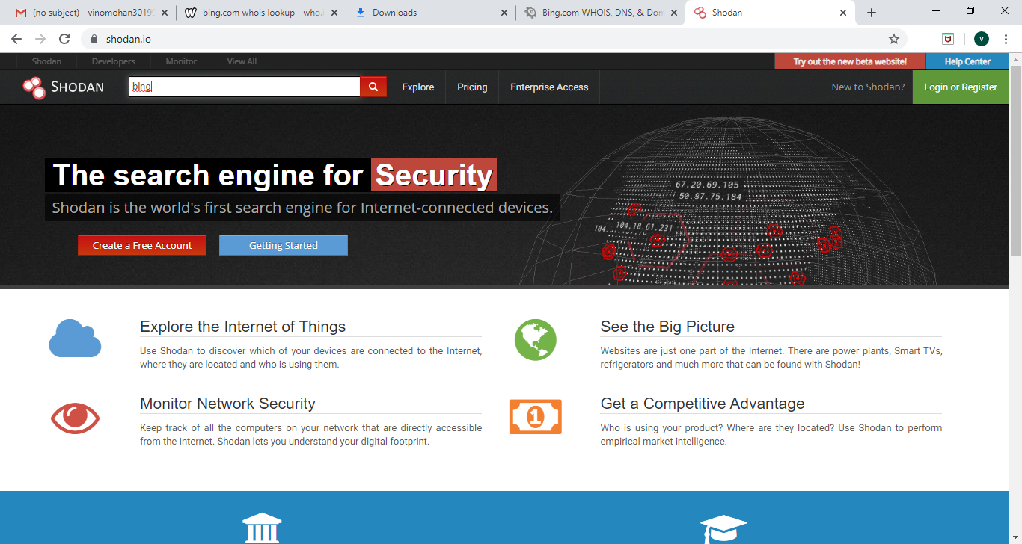

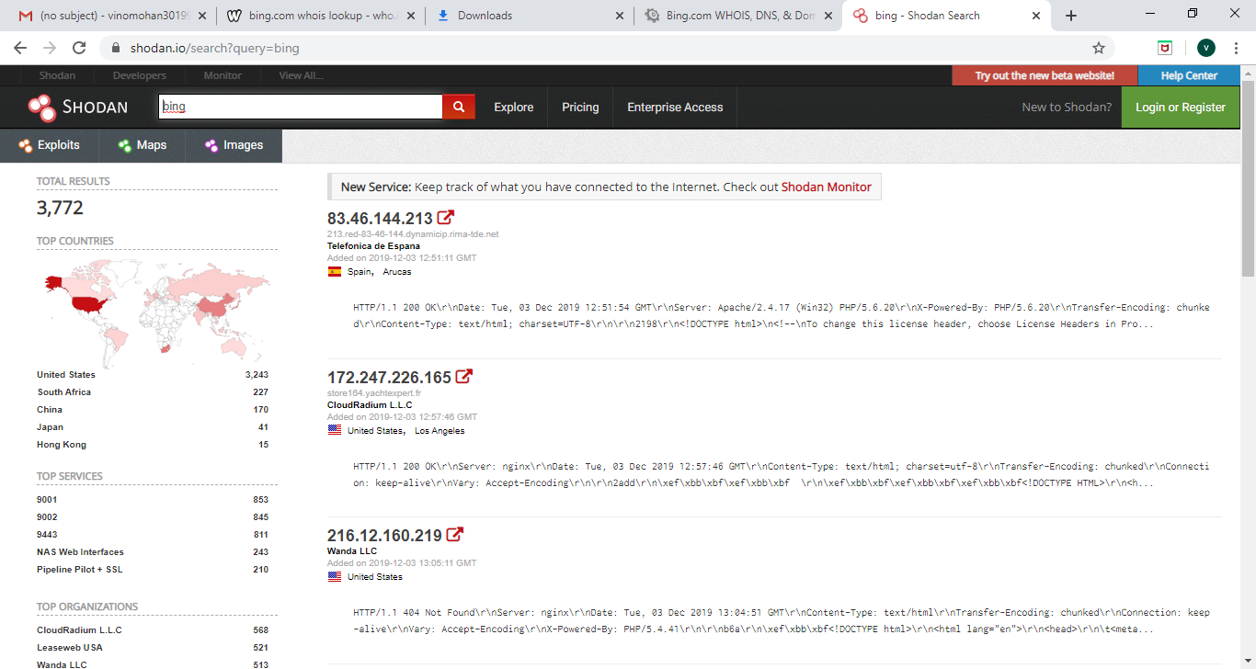

1. **Who.is-Visit** [**https://who.is/**](https://who.is/) **and search for the particular website.**

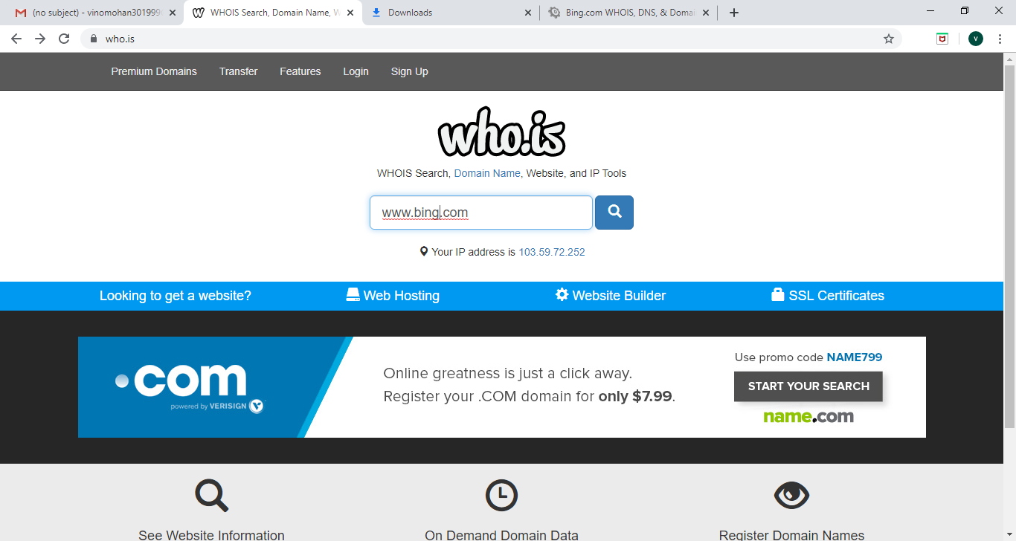

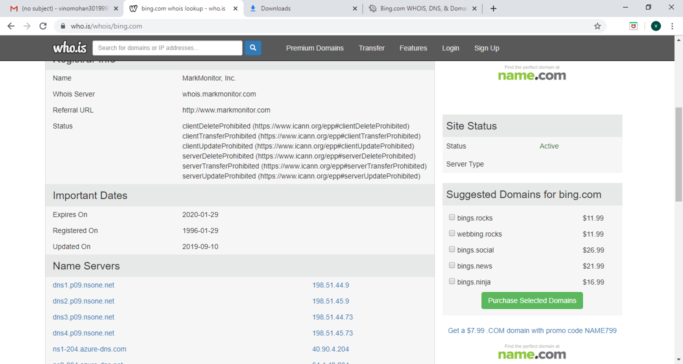

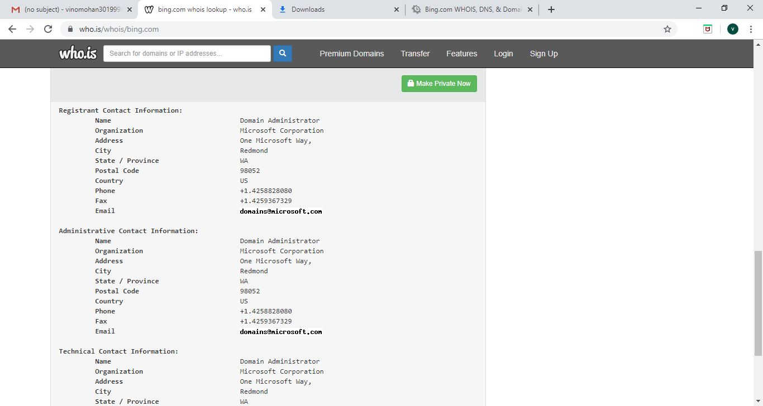

1. **Anywho-Visit** [**https://www.anywho.com/whitepages**](https://www.anywho.com/whitepages) **and search for the required address, name or phone no of a particular person.**

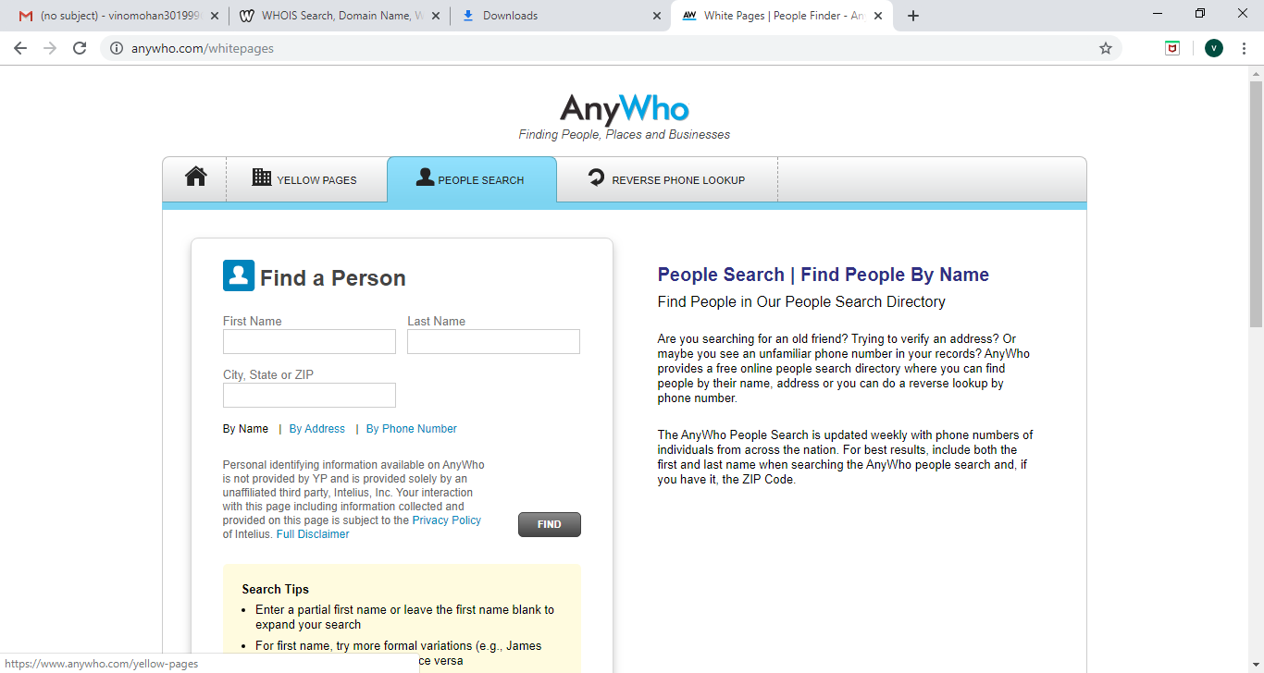

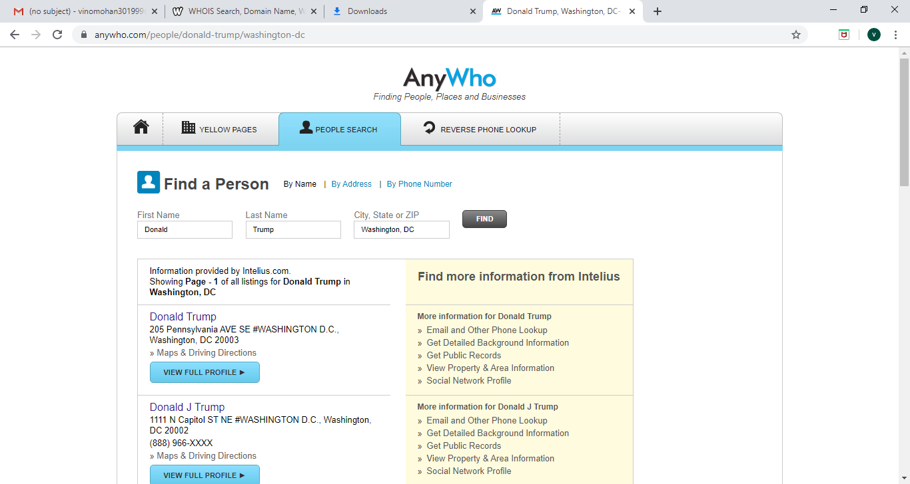

1. **Whoislookup- Vist** [**http://whois.domaintools.com/**](http://whois.domaintools.com/) **and check for the ip or domain.**

